**Linear Regression Model Selection and Interpretation**

We are interested in analyzing which factors are determinant to movies’ gross earnings. We collected the data on movies to study this question.

Before we built the model, we analyzed the data and selected the appropriate variables. Since we would like to utilize the entire sample, we did not use variables with a high percentage of missing values such as aggregate followers. In addition, we do not have proxy for aggregate followers in order to impute these missing data.

We also looked at different interesting trends between Gross earnings and other explanatory variables. We found that Gross earnings have strong positive relationships with other variables such as Ratings, Budget, Views and Screens (see Figure 1-4 below).

**Figure 1: Gross earnings and Ratings with Sequel group**

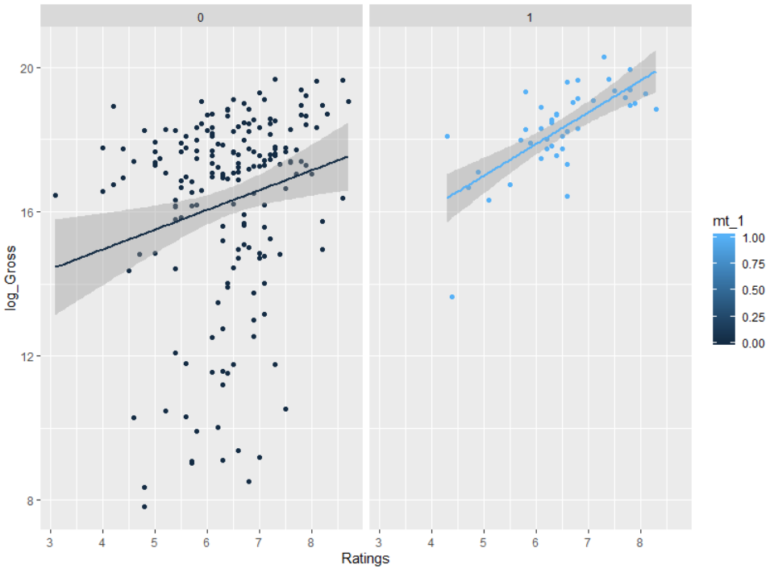

**Figure 2: Gross earnings and Budget**

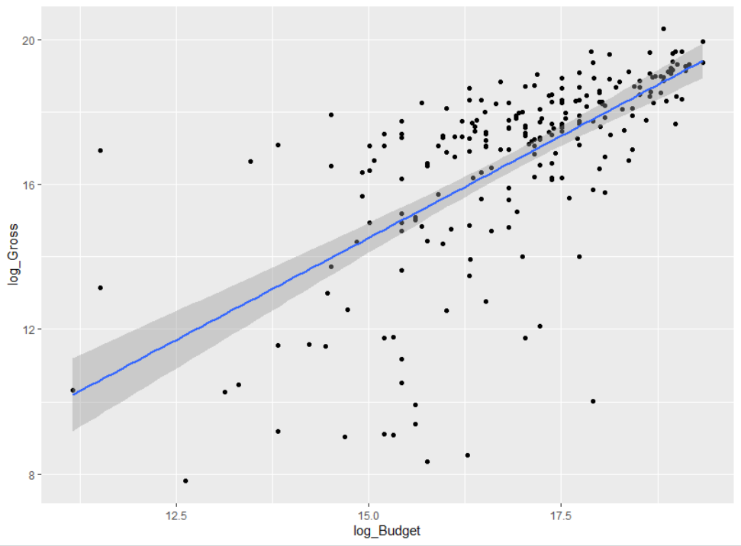

**Figure 3: Gross earnings and Views**

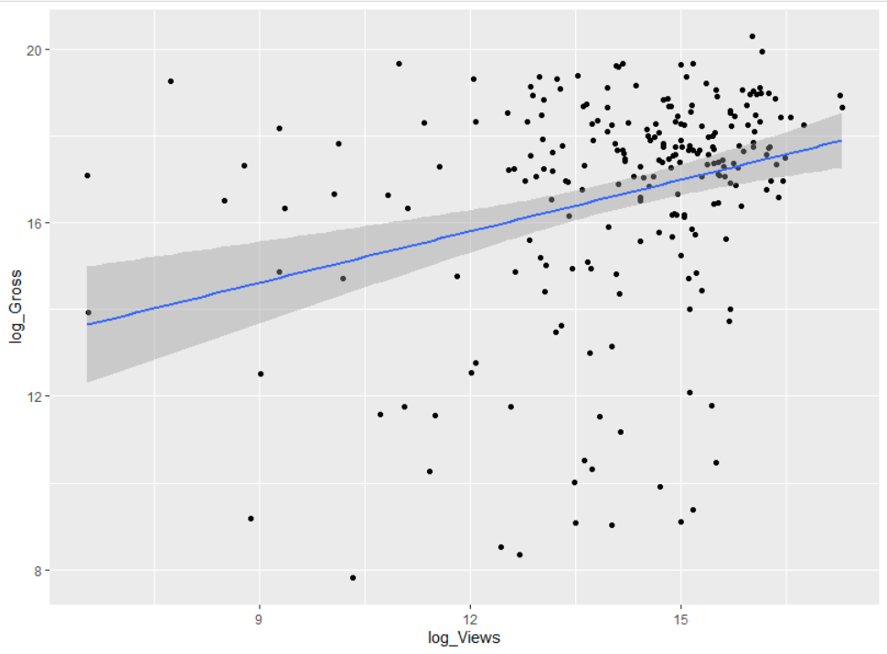

**Figure 4: Gross earnings and Screens**

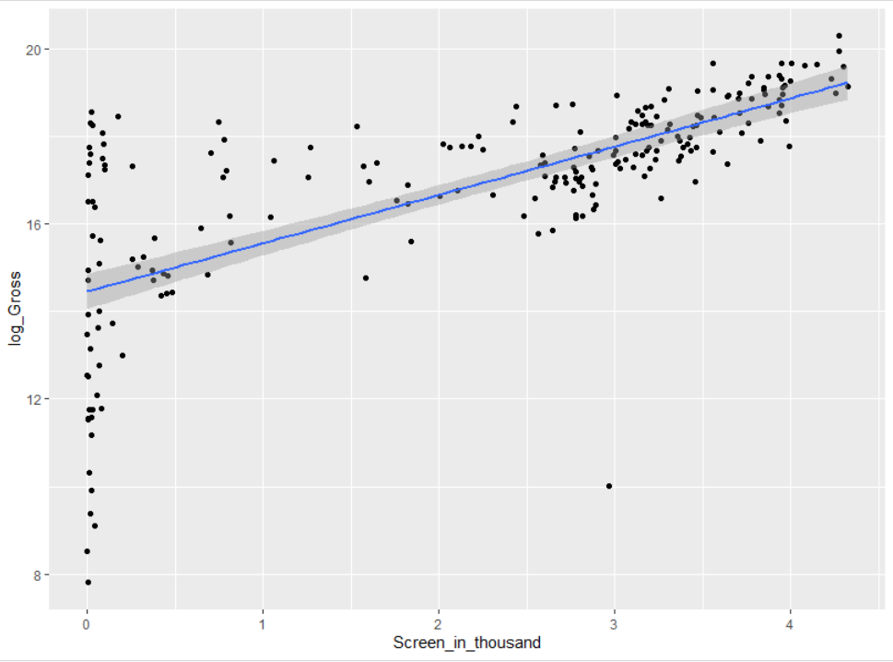

Next, we looked at the correlation of the variables. For example, we noticed that Views, Likes, Dislikes, and Comments are highly correlated. Therefore, we could not use all of them but we can use one of them to capture the effect of how many audience members are interested in these movies. First, we tried to change the units for Likes (into thousands), Dislikes (into thousands, and Views (into millions), but only Dislikes into thousands is significant at 10%. We then tried log of views and it is significant at 9%. We wanted to capture Views rather than Dislikes because it is more significant and captures the whole audience of the movies rather than just the negative points of view. Moreover, the models with log(Views) has lower RMSE than models with Dislikes in thousands.

We ran different models using various selection methods such as: backward selection, forward selection, and step-wise selection. We found that only the following variables were statistically significant simultaneously: Ratings, more than one Sequel, log of Budget, log of Views, and Screens in thousands. In addition, we found that the slope on the Ratings are different for one Sequel versus more than one Sequel when we ran with the whole sample. Therefore, we allowed for the interactions (see Table 1 and Table 2 for estimation results).

**Table 1: Estimation Results on the Whole Sample**

Based on the results, we can write the estimated equation as follows:

$$\hat{\log\left(Gross\right)}=4.423+0.366*Ratings+4.06*mt_1-0.546*Ratings*mt_1+0.4*\log\left(Budget\right)+0.0995*\log\left(Views\right)+0.805*Screen_in_thousands$$

The estimated return to ratings for movies with a single sequel is 0.366 or 36.6%. For movies with more than one sequel, it is 0.366-0.5455 = -0.18 or about -18%. The difference in estimated return to ratings between movies with a single sequel and movies with more than one sequel is pretty large and statistically significant at 5%. So we can see that there is evidence against the return to ratings is the same for movies with one sequel vs. movies with more than one sequel.

The coefficient on more than 1 sequel implies that, for the same levels of ratings, budget and views, movies with more than 1 sequel earns about 400% higher than movies with only 1 sequel. We can even compute the exact percentage difference in predicted gross earning between movies with a single sequel and movies with more than one sequel. On average, the predicted gross earnings of movies with more than one sequel is (exp(4.06)-1)*100% = 5697.43% higher than the predicted gross earnings of movies with one sequel.

When Budget increases by 1%, Gross earnings grow by 0.4% holding other factors constant. In addition, when Views increases by 1%, Gross earnings rise by around 0.1%. And when movies are displayed in one thousand of Screens, Gross earnings increase by approximately 100*(exp(0.805)-1) = 123.67%

**

**Table 3: Estimation Results on the Training data**

**Table 4: ASE and RMSE for the Training data**

**Table 5: Estimation Results on the Training data**

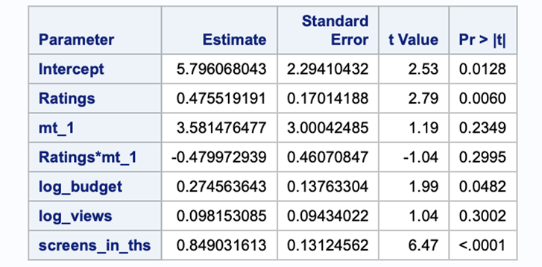

Based on the results for the training data, we can write the estimated equation as follows:

$$\hat{\log\left(Gross\right)}=5.796+0.475*Ratings+3.58*mt_1-0.48*Ratings*mt_1+0.275*\log\left(Budget\right)+0.098*\log\left(Views\right)+0.849*Screen_in_thousands$$

The estimated return to ratings for movies with a single sequel is 0.475 or 47.5%. For movies with more than one sequel, it is 0.475-0.48 = -0.005 or about -0.5%. The difference in estimated return to ratings between movies with a single sequel and movies with more than one sequel is trivial and not statistically significant at 5%. So we can see that there is no evidence against the return to ratings is the same for movies with one sequel vs. movies with more than one sequel. This could be due to a small sample size in the training data. If we have a large sample size, the interaction might be statistically significant and we can consider the previous interpretation above from the whole sample.

The coefficient on more than 1 sequel implies that, for the same levels of ratings, budget and views, movies with more than 1 sequel earns about 358% higher than movies with only 1 sequel. We can even compute the exact percentage difference in predicted gross earning between movies with a single sequel and movies with more than one sequel. On average, the predicted gross earnings of movies with more than one sequel is (exp(3.58)-1)*100% = 3487.35% higher than the predicted gross earnings of movies with one sequel.

When Budget increases by 1%, Gross earnings grows by 0.275% holding other factors constant. In addition, when Views increases by 1%, Gross earnings rises by around 0.098%. And when movies are displayed in one thousand of screens, Gross earnings increases by approximately 100*(exp(0.849)-1) = 133.73%.

The interpretation is similar between the training data and the whole sample, except for the interaction between ratings and sequel due to small sample size. Hence, we can see the results are robust for all variables in the sample.

All models that we tried in this particular section are linear models. When we compared different linear models with different specifications, the model shown above is the best model with the lowest RMSE, at 53 million (see Table 4 above).

**Appendix**

**SAS Code for Linear Regression Model**

proc import datafile = "/home/aburnett2/Stat 2 Project File-Movie/movie.csv" out = mv dbms=csv replace;

run;

proc contents data=mv; run;

data new;

set mv;

log_gross = log(Gross);

if Sequel=1 then mt_1=0; else mt_1=1;

log_budget = log(Budget);

log_views = log(Views);

screens_in_ths = Screens/1000;

run;

proc surveyselect data= new samprate=.6 seed = 123 out=new_out outall;

run;

data mv_training;

set new_out;

if selected=1;

run;

data mv_testing;

set new_out;

if selected=0;

run;

proc glm data=mv_training;

model log_gross = Ratings|mt_1 log_budget log_views screens_in_ths /solution;

output out=mv_train_result p=pred r=r;

title "GLM on training data";

run;

data mv_train_result1;

set mv_train_result;

gross_pred = exp(pred);

train_ressq = (Gross - gross_pred)**2;

run;

proc means data=mv_train_result1 mean;

var train_ressq;

output out=train_stats mean=ASE_train;

title "ASE from training data";

run;

data train_stats1;

set train_stats;

RMSE_train = sqrt(ASE_train);

run;

proc print data=train_stats1;

var ASE_train RMSE_train;

title "ASE and RMSE from training data";

run;

* Get prediction and accuracy for the testing data;

proc glm data=mv_testing;

model log_gross = Ratings|mt_1 log_budget log_views screens_in_ths /solution;

output out=mv_test_result p=pred r=r;

title "GLM on testing data";

run;

data mv_test_result1;

set mv_test_result;

gross_pred = exp(pred);

test_ressq = (Gross - gross_pred)**2;

run;

proc means data=mv_test_result1 mean;

var test_ressq;

output out=test_stats mean=ASE_test;

title "ASE from testing data";

run;

data test_stats1;

set test_stats;

RMSE_test = sqrt(ASE_test);

run;

proc print data=test_stats1;

var ASE_test RMSE_test;

title "ASE and RMSE from testing data";

run;

**R Code for Linear Model Plots and Graphs**

mv$log_Gross =log(mv$Gross)  
  
mv$log_Budget =log(mv$Budget)  
mv$log_Views =log(mv$Views)  
mv$Screen_in_thousand = (mv$Screens)/1000  
mv$mt_1 <- ifelse(mv$Sequel == 1, 0, 1)  
  
#Figure 1  
ggplot(mv, aes(Ratings, log_Gross, color=mt_1)) +  geom_point() +  facet_wrap( ~ mt_1) + geom_smooth(method="lm")  
  
*ggplot(mv, aes(Ratings, log_Gross, color=mt_1)) + stat_smooth(method="glm", formula=y~x, alpha=0.2, size=2, aes(fill=mt_1)) + geom_point(position=position_jitter(height=0.01, width=0)) + xlab("Ratings") + ylab("Log_Gross")  
  
#Figure 2  
ggplot(mv, aes(x = log_Budget, y = log_Gross)) +  geom_point()  + geom_smooth(method="lm")  
  
#Figure 3  
ggplot(mv, aes(x = log_Views, y = log_Gross)) +  geom_point()  + geom_smooth(method="lm")  
  
#Figure 4  
ggplot(mv, aes(x = Screen_in_thousand, y = log_Gross)) +  geom_point()  + geom_smooth(method="lm")